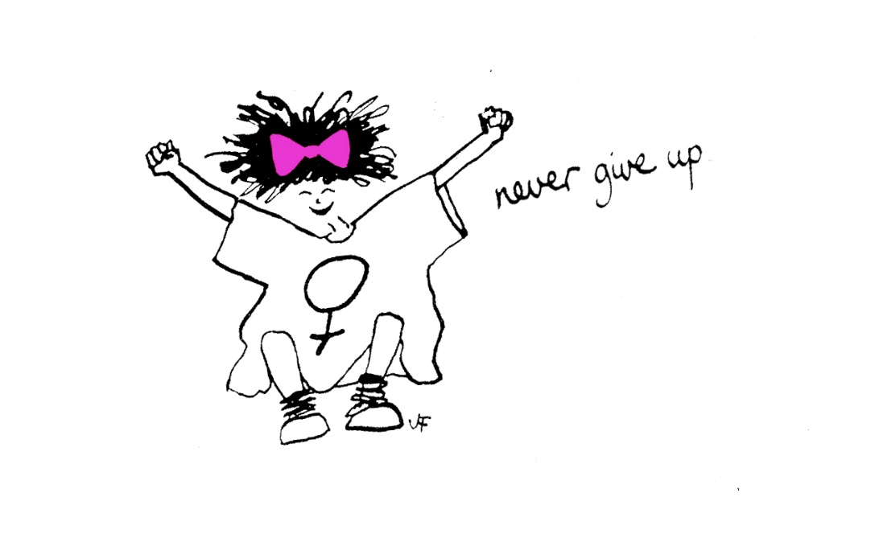

Evaluation of The Freedom Programme 5 – Online
January – April 2022.
Sharon Bryan Consultancy Community Interest Company.
Company Number: 12882606.

Introduction
This evaluation examines the efficacy of The Freedom Programme. Through a quantitative assessment, this evaluation examines the impact and outcomes of the Freedom Programme for participants of the online group programme, which was conducted between January and April 2022.

Impact of COVID-19 and subsequent lockdowns.
With the inception of the COVID-19 pandemic and subsequent national lockdowns, the Freedom Programme was not able to run in the normal way, which has historically been face to face group sessions. Instead, login details for the Freedom Programme Online were purchased for £12 each and given to the women that had been offered a place on the online group programme, along with instructions on how to access the online programme on the national Freedom Programme website.
Conducting the programme online has its advantages and its disadvantages! The main disadvantage is that the group sessions lack the physical connection that women often feel is important.
“It is harder to connect with the other women when it is online. I think it would have been nice to have been able to give each other a cuddle when one of us became upset, but obviously, we can’t do that online”.
The obvious advantages of the programme being online are that women can attend from anywhere in the country or even the world! It is much more cost effective to run a programme online as there are no fees for venue hire or childcare. When a physical programme is run, we also give out copies of ‘Living with the Dominator’ and ‘The Home Study Course’ to each woman. By giving the women access to the online programme, they have access to the same content, but this is also cheaper to purchase than the books. For the women, there is obviously the advantage of not having to travel or leave their homes. However, this can be a disadvantage for women who are still living with the abusive partner or who have children who are not in school, particularly during the pandemic when schools were closed.
As we now emerge from the pandemic and adapt to new kinds of ‘normal’, some Freedom Programmes will now go back to being face to face. I, however, have chosen to continue to run mine virtually and welcome women from anywhere.

Aims of The Freedom Programme.
The Freedom Programme is a support group designed for women who are or have been experiencing domestic abuse. The Freedom Programme is designed as an intervention to empower women to make positive choices about their lives by providing information and support, within a group setting. It gives women an opportunity and space to develop ways of thinking and behaving to protect themselves and their children from harm.
The aims of The Freedom Programme are:
- To help women understand the beliefs held by abusive men and in doing so, recognise which of these beliefs they have shared.
- To illustrate the effects of domestic abuse on children.
- To assist women to recognise potential future abusers.
- To help women gain self-esteem and the confidence to improve the quality of their lives.
- To introduce women to other women who share similar experiences.
The Freedom Programme comprises 11, 90-minute sessions held weekly and run by a qualified facilitator.
The Freedom Programme was developed in the UK by Pat Craven who works in the area of domestic abuse.

Evaluation Methodology
The information was collated using client questionnaires with qualitative and quantitative questions.

Process
- The client questionnaires were sent out by email after 9 sessions of the programme had been completed.
- Attendees were told there was no obligation to complete the questionnaire.

Response Rate
There were 10 women who completed The Freedom Programme. Of these women, all of them completed at least 6 sessions of the programme.

Main Findings
The analysis was very positive. The main quantitative findings are outlined below.
- 100% of participants said The Freedom Programme had a positive impact on their lives.
- Eight of the participants said they found The Freedom Programme very helpful, and two found it helpful.

Because of their participation in The Freedom Programme
- Seven participants strongly agreed, that the programme has resulted in a positive change in their lives and three agreed.
- Eight participants strongly agreed they are more hopeful for the future and two agreed
- Five participants strongly agreed that they are more assertive. Four agreed and one disagreed because she still felt she was being controlled by her ex-partner and further abused through the courts.
- Seven participants strongly agreed that they were more confident and three agreed.
- Six participants strongly agreed they no longer blame themselves for their abuser’s behaviour and four agreed.
- Eight participants strongly agreed that they can now make more sense of their abusers’ behaviour and two agreed.
- Eight participants strongly agreed they now feel less along in their experience of domestic abuse and two agreed.
- Nine participants strongly agreed and five agreed that they expect to be more respected and one agreed.
- Eight participants strongly agreed that they can now recognise and identify abusive behaviour and two agreed.
- Four participants strongly agreed that they feel they have the ability to respond to abusive behaviour, five agreed and one disagreed as she did not feel at that stage yet.
- Eight participants strongly agreed that they could now recognise an unhealthy relationship and two agreed.
- Six participants strongly agreed that they understood more about the impact of domestic abuse on children and four agreed.
As well as the quantitative findings, women had the opportunity to explain their reasons for selecting their answers. The main themes that emerged from the qualitative questions were:
Detailed Analysis
Overall impact of The Freedom Programme
The overall impact was very positive with 100% of those who completed the questionnaire saying that The Freedom Programme had a positive impact on their lives.
- “I think the most helpful aspect is identifying the techniques of the dominator and connecting with other women who have had a similar experience. I think it is invaluable. However, maybe techniques with how to deal with the dominator in a non-confrontational manner for those still with them”.
- “Before the programme, I thought the conduct that was directed towards me was unique to me and because of something I had done or because of something in me. In this, the programme has reduced the isolation and shame that went with the misconception”.
- “Deconstructing the mechanics and beliefs of both parties has also been quite a powerful tool to start to move out of the ‘victim’ identity and reduce vulnerability to further abuse going forward”.
- “Sharing, listening and supporting other women with similar experiences has been very positive and helped reduce and refocus the isolating effects of the abuse”.
- “Gaining knowledge is important, as well as the supportive environment of the group to be able to discuss personal experiences and learn coping skills and important legal information”.
- “Specifically, outlining each unhealthy trait of an abuser”.
- “Understanding that there are some horrible nasty men out there and where there troubles can come from. It’s interesting with the video’s showing the domestic violence man to a different man that is kind and caring”.
- “Very helpful because I see other women in the same situation as me. Going through the same or similar things”.
- “It is a way to open your eyes, to see many things about toxic relationships and the impact of this on your life”.
- “It contributed significantly to increasing my self confidence and self worth”.
- “Better understanding of abuse and recognition of behaviours. Connection and validation with other survivors”.
- “As a support system, connection and support. Empathy and understanding. I made friends. I learned about abusive behaviours and I felt educated and empowered”.
What were the impacts of The Freedom Programme?
- “I found it very helpful to connect with other women who share their own unique but startingly similar differences”.
- To see different perspectives, issues and concerns, all facilitated and answered by Sharon”.
- I realise (unfortunately) that abusive men have very similar characteristics/behaviours/traits/patterns, that seemed to be common in the group. Although this is unsettling, they seem to be a certain type. It, therefore, makes them easier to spot”.
- “More confidence and self-esteem, less isolated, less fear, less shame”.
- “Realising that I was by no means alone. That other women were experiencing the same manipulation and that I really wasn’t insane!”.
- “I feel more confident, more sure on that is what I do not want again in my life”.
- “Made me more confidant that I was telling the truth. That it really did happen, that it is not going to stop if I go back”.
- “Learning what other women have gone through and how it has affected them. My domestic violence hasn’t been as severe as others. But it happened and I have moved on from this”.
- “Understanding unhealthy male traits and how women are also allowing these traits to be normalised”.
- “Able to spot and respond to unhealthy behaviours in intimate relationships”.
- “Strengthened my resolve that leaving was the right thing. It made me feel less isolated and less alone in my experience and it helped me identify some of the techniques that had been used on me”.

Which session did you find most useful?
- “All of them. Especially Headworker and Bully”.
- “Badfather – What I had always thought of as laziness and poor parenting. It has helped me to recognise it is part of the power and control dynamic”.
- “the Sexual Controller”.
- “The Headworker”.
- All of them. Especially when we shared our experiences”.
- “I think it would be The Liar”
- “The Badfather and The Liar”.
- “I found all of the sessions useful”.
- “It is hard to choose but I have found the King of the Castle, The Jailor, The Badfather and The Pursuader all incredibly helpful. The penultimate session which focused on the cycle of abuse through breaking the tacit rules really helped me to get to grips with the pattern and the triggers and immediate consequences in a way I think will help me going forward”.
- “The Bully and The Headworker because they focused on some of the most subtle but constant issues”.
Which session did you find least useful?
- “The Badfather but probably because I don’t have children”.
- “The Sexual Controller”.
- “I found each session equally useful”.
- “The Sexual Controller”.
- “None”.
- “None, all are interesting”.
- “I found them all very useful”.
- “The Sexual Controller”.
- “The one regarding children, for the sheer fact that I don’t have any! But the opening video was probably the most upsetting of them all”.
Other suggestions/feedback
Participants were asked for any other comments or feedback.
- Invaluable to connect with other women and how quicky we bonded and supported one another”.
- “Sharon is like a fairy godmother and guardian angel rolled into one beautiful package!”
- “I’m so glad I was introduced to this programme and accepted to join.I feel it has really helped me. The way Sharon supported us all and the other ladies supported each other was incredibly heart-warming”.
- “An extremely positive experience which I hope more women in need will be able to participate in and benefit from. Very grateful for Sharon and everyone’s support”.
- “I can not recommend Sharon highly enough. She has been a skilled and sensitive facilitator with a depth and breadth of personal and professional experience that she has shared and directed to the benefit of every woman in the group. She has been sensitive to the different situations, experiences of abuse and values of the different women in the group and has offered several, including myself, additional support in a voluntary capacity over particularly difficult situation”.
- “Sharon has sensitivity and appropriately challenged, in a structured and supportive way some of the misconceptions and perspectives that unintentionally create the opportunity for abuse or make its effects worse”.
- “Sharon has skilfully managed triggering material during group sessions and made sure every women felt safe, supported and included during each session”.
- “Sharon has been empowering, facilitated new connections and supportive friendships and that kept things pointing towards the positive throughout the programme”.
Conclusion
This evaluation of The Freedom Programme is extremely positive. The programme was conducted in the evening to allow women to settle young children. This seemed to work very well.
Obviously, with the nature of the programme, there were times when participants became distressed, when speaking about their experiences. Being an online virtual programme there was clearly an absence of being able to physically reassure and comfort women in the group – something I feel is a disadvantage of holding the programmes virtually. However, as with the last group programme members the women in this programme set up a WhatsApp group between them so that they could message each other in between sessions, if they felt they needed extra support. I am part of this group but only for the purposes of monitoring it and the women knew this.
Overall, all women who attended and completed the programme stated that they felt more empowered and ready to face the future with more understanding of their experiences.

Sharon Bryan
Sharon Bryan Consultancy Community Interest Company
Company Number: 12882606
July 2021.

