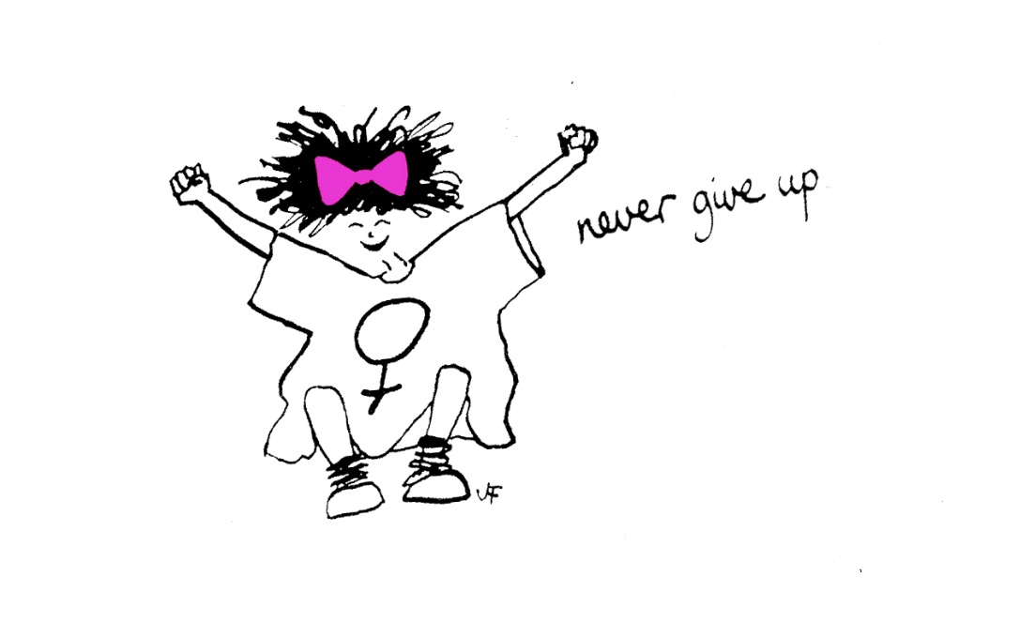

Evaluation of The Freedom Programme – Online
September - November 2021.
Sharon Bryan Consultancy Community Interest Company.
Company Number: 12882606.

Introduction
This evaluation examines the efficacy of The Freedom Programme. Through a quantitative assessment, this evaluation examines the impact and outcomes of the Freedom Programme for participants of the online group programme, which was conducted between September and November 2021.

Impact of COVID-19 and subsequent lockdowns.
With the inception of the COVID-19 pandemic and subsequent national lockdowns, the Freedom Programme was not able to run in the normal way, which has historically been face to face group sessions. Instead, login details for the Freedom Programme Online were purchased for £12 each and given to the women that had been offered a place on the online group programme, along with instructions on how to access the online programme on the national Freedom Programme website.
Conducting the programme online has its advantages and its disadvantages! The main disadvantage is that the group sessions lack the physical connection that women often feel is important.
“It is harder to connect with the other women when it is online. I think it would have been nice to have been able to give each other a cuddle when one of us became upset, but obviously, we can’t do that online”.
The obvious advantages of the programme being online are that women can attend from anywhere in the country or even the world! It is much more cost effective to run a programme online as there are no fees for venue hire or childcare. When a physical programme is run, we also give out copies of ‘Living with the Dominator’ and ‘The Home Study Course’ to each woman. By giving the women access to the online programme, they have access to the same content, but this is also cheaper to purchase than the books. For the women, there is obviously the advantage of not having to travel or leave their homes. However, this can be a disadvantage for women who are still living with the abusive partner or who have children who are not in school, particularly during the pandemic when schools were closed.
As we now emerge from the pandemic and adapt to new kinds of ‘normal’, some Freedom Programmes will now go back to being face to face. I, however, have chosen to continue to run mine virtually and welcome women from anywhere.

Aims of The Freedom Programme.
The Freedom Programme is a support group designed for women who are or have been experiencing domestic abuse. The Freedom Programme is designed as an intervention to empower women to make positive choices about their lives by providing information and support, within a group setting. It gives women an opportunity and space to develop ways of thinking and behaving to protect themselves and their children from harm.
The aims of The Freedom Programme are:
- To help women understand the beliefs held by abusive men and in doing so, recognise which of these beliefs they have shared.
- To illustrate the effects of domestic abuse on children.
- To assist women to recognise potential future abusers.
- To help women gain self-esteem and the confidence to improve the quality of their lives.
- To introduce women to other women who share similar experiences.
The Freedom Programme comprises 11, 90-minute sessions held weekly and run by a qualified facilitator.
The Freedom Programme was developed in the UK by Pat Craven who works in the area of domestic abuse.

Evaluation Methodology
The information was collated using client questionnaires with qualitative and quantitative questions.

Process
- The client questionnaires were sent out by email after 9 sessions of the programme had been completed.
- Attendees were told there was no obligation to complete the questionnaire.

Response Rate
There were 12 women who completed The Freedom Programme. Of these women, all of them completed at least 6 sessions of the programme.

Main Findings
The analysis was very positive. The main quantitative findings are outlined below.
- 100% of participants said The Freedom Programme had a positive impact on their lives.
- Eight of the participants said they found The Freedom Programme very helpful, and four found it helpful.

Because of their participation in The Freedom Programme
- Seven participants strongly agreed, that the programme has resulted in a positive change in their lives and five agreed.
- Seven participants strongly agreed they are more hopeful for the future and five agreed
- Seven participants strongly agreed that they are more assertive. Four agreed and one disagreed because she had only been out of the abusive relationship for a short time and felt she needed longer to feel assertive.
- Six participants strongly agreed that they were more confident and six agreed.
- Five participants strongly agreed they no longer blame themselves for their abuser’s behaviour and seven agreed.
- Eight participants strongly agreed that they can now make more sense of their abusers’ behaviour and four agreed.
- Ten participants strongly agreed they now feel less along in their experience of domestic abuse and two agreed.
- Eleven participants strongly agreed and five agreed that they expect to be more respected and one agreed.
- Nine participants strongly agreed that they can now recognise and identify abusive behaviour and three agreed.
- Eight participants strongly agreed that they feel they have the ability to respond to abusive behaviour and four agreed.
- Eight participants strongly agreed that they could now recognise an unhealthy relationship and four agreed.
- Ten participants strongly agreed that they understood more about the impact of domestic abuse on children and two agreed.
As well as the quantitative findings, women had the opportunity to explain their reasons for selecting their answers. The main themes that emerged from the qualitative questions were:
Detailed Analysis
Overall impact of The Freedom Programme
The overall impact was very positive with 100% of those who completed the questionnaire saying that The Freedom Programme had a positive impact on their lives.
- “Has shown me the signs to look our for when I am ready for a new partner”.
- “It as made me aware and really reinforced my awareness of the behaviours of my ex and how it isn’t normal. It is unhealthy and toxic and it isn’t love in any form”.
- “Helpful – an opportunity to discuss, listen, learn and not feel alone or shame”.
- “Although I didn’t open up as much as I liked I couldn’t wait for the next session to come and it made so much easier discussing domestic violence with people who have been through that and not judging you. I was thinking that my ex-partner mental health was the main drive for his behaviour but now I see that its not just that and before everything escalated and he became violent and controlling there were little things that were actually warning signs. However, I did miss them, just because that was accepted as a normal male behaviour especially when there was no physical abuse and obvious signs of control”.
- “It helped me a lot to build self-confidence, after knowing I am not the only one”.
- “It finally gave me the ‘freedom’ which I was looking for. I have tried counselling (with a counsellor and a psychiatrist), hypnotherapy, reading books and despite all those sessions, and while they helped, I needed something extra to give me the push to achieve freedom from my ex. The FP most certainly did that and more”.
- “It teaches you to recognise the red flags and so we are more aware of the types of abuse. I now will never put up with this behaviour ever again”.
- “It got me to go to a refuge”.
- “It has given me more confidence and awareness to spot the signs and now to see them for what they are rather that what they are designed to be”.
- “Made me feel slightly less alone and isolated”.
What were the impacts of The Freedom Programme?
- “It made me realise his actions were not my fault”.
- “Better awareness of all behaviours associated with all forms of domestic abuse including the confidence to spot them”.
- “It has helped me to recognise all types of domestic abuse and to trust my gut instincts. It has made me feel that I am not alone and there is help out there”.
- “Directly after the first session, I felt a sense of empowerment. I think that was down to understanding the behaviours of the perpetrator and discussing it within a secure and supportive forum”.
- “To feel that I am not alone”.
- “More awareness of domestic violence forms”.
- “Feeling more aware and confident, not doubting myself as much as before. Connecting with other women who survived/are surviving domestic abuse made me realise this could happen to every woman no matter what age, religion, occupation etc”
- “Helping me see aspects of the abuser’s behaviour as unreasonable and realising that I’m not weak, nor are the other women who have experienced physical/emotional abuse”.
- “It has given me the strength to cut all ties with my ex and to go forward with getting a non-molestation order and also shown me what red flags to look out for with future relationships. It has helped me to feel strong and rebuild some self-esteem”.
Which session did you find most useful?
- “The effects of DV on children”.
- “The jailor and The Headworker”.
- “The bad father and the sexual controller. Even having done the programme before until doing the programme again this time I was 100% sure these topics didn’t apply to me but Sharon and the other women have really opened my eyes and although not all the tactics of these behaviours apply, I am now able to see how he was. The session on the effects on children was also very enlightening. I believed I had protected my daughter from his abuse but I see now how even though she didn’t see, she still lived through it and I was unable to really shield her. I know better now for the future”.
- “All useful – none stood out from the other”.
- “The effects on children and The Liar. Also the sexual controller just because before the session I didn’t think that this particular chapter related to me but then I found some parts that actually I did experience”.
- “King of the Castle”.
- “I can’t pick a favourite, they were all informative and useful”.
- “The Bad father and the impact on children”.
- “All of them”.
- “All of them for identifying the individual behaviours and breaking them down to be more obvious”.
- “The Persuader”.

Which session did you find least useful?
- “The effects on children. It was a hard session”.
- “The sexual controller as I felt sick when I heard words he used to say and I did not know they are common. It took me back suddenly to those painful moments and I felt sick”.
- “All of them were useful to me”.
- “All useful”.
Other suggestions/feedback
Participants were asked for any other comments or feedback.
- “I felt the sessions went very well, there was a feeling of inclusion. I learnt a lot. I realised a lot. Thank you very much”.
- “I found Sharon to be amazing, very supportive and understanding. Especially when she is able to give examples from her own past. She is easy to relate to and talk to. She offers advice not just around the sessions but on things we have going on e.g. court etc and tells us where we can get help and she really brings the group together well so even though it is online, we feel included”.
- I really got a lot from the programme”.
- “Sharon was lovely, very supportive and interesting to listen to”.
- “I think this course is good at showing abusive traits and showing the healthy traits of a person too. It would be helpful to know how to work through awareness and onto the next stage of recovery – e.g. things that still keep you with the abuser such as co-dependency, learning how to be more assertive or suggested links to therapists/coaches that specialise in complex post traumatic stress from repetitive psychological abuse etc”.
- “I would like to attend another programme to make up for the sessions I missed”.
- “Sharon was excellent, highly experienced and knowledgeable about the subject”.
- “Maybe have a little more about modern technology/online dating etc. How the perpetrator can use technology as a vehicle in the abuse. Also, perhaps a session from a police officer within the programme to do a speech (even if it is a recorded video) to support ladies reporting domestic abuse. That is the one thing I regret not doing. I was too afraid to report him”.
- “It was brilliant being able to do this online. If I had had to travel I would not have been able to attend”.
- “Being online the FP will be more accessible to ladies who require it and no need to book a babysitter either!”.
- “I really enjoyed and looked forward to every session. It was also lovely to meet other women who are going through a similar situation to myself”.
- “Maybe cover parenting issues and how to deal with legal and caring issues with children and abusive fathers”.
- “It would be a great idea to give the option of continuing with a survival support group as it is a long road which can not be resolved or healed in 11 weeks”.

Conclusion
This evaluation of The Freedom Programme is extremely positive. The programme was conducted in the evening to allow women to settle young children. This seemed to work very well.
Obviously, with the nature of the programme, there were times when participants became distressed, when speaking about their experiences. Being an online virtual programme there was clearly an absence of being able to physically reassure and comfort women in the group – something I feel is a disadvantage of holding the programmes virtually. However, as with the last group programme members the women in this programme set up a WhatsApp group between them so that they could message each other in between sessions, if they felt they needed extra support. I am part of this group but only for the purposes of monitoring it and the women knew this.
Overall, all women who attended and completed the programme stated that they felt more empowered and ready to face the future with more understanding of their experiences.

Sharon Bryan
Sharon Bryan Consultancy Community Interest Company
Company Number: 12882606
July 2021.

