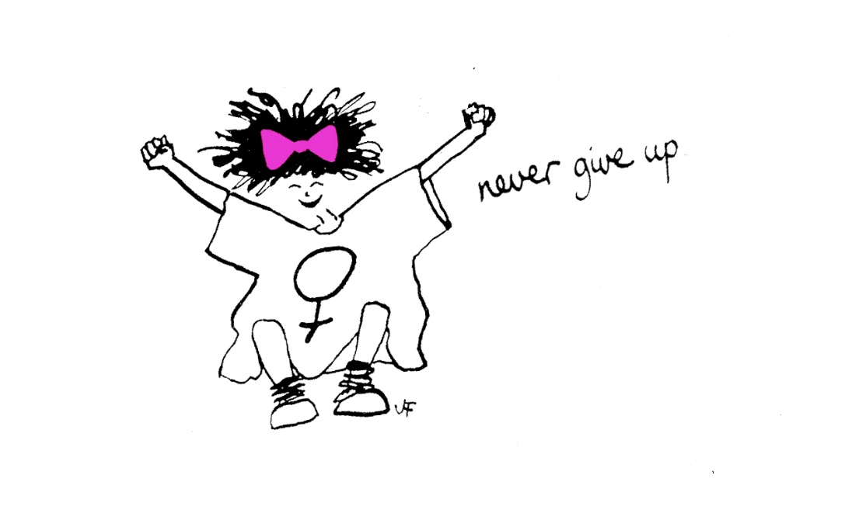

Evaluation of The Freedom Programme – Online
May to July 2021.
Sharon Bryan Consultancy Community Interest Company.
Company Number: 12882606.

Introduction
This evaluation examines the efficacy of The Freedom Programme. Through a quantitative assessment, this evaluation examines the impact and outcomes of the Freedom Programme for participants of the online group programme, which was conducted between May 2021 and July 2021.

Impact of COVID-19 and subsequent lockdowns.
Since the inception of the COVID-19 pandemic and subsequent national lockdowns, the Freedom Programme has not been able to run in the normal way, which has historically been face to face group sessions. Instead, login details for the Freedom Programme Online are purchased for £12 each and given to the women that have been offered a place on the online group programme, along with instructions on how to access the online programme on the national Freedom Programme website.
Conducting the programme online has its advantages and its disadvantages! The main disadvantage is that the group sessions lack the physical connection that women often feel is important.
“It is harder to connect with the other women when it is online. I think it would have been nice to have been able to give each other a cuddle when one of us became upset, but obviously, we can’t do that online”.
The obvious advantages of the programme being online are that women can attend from anywhere in the country or even the world! It is much more cost effective to run a programme online as there are no fees for venue hire or childcare. When a physical programme is run, we also give out copies of ‘Living with the Dominator’ and ‘The Home Study Course’ to each woman. By giving the women access to the online programme, they have access to the same content, but this is also cheaper to purchase than the books. For the women, there is obviously the advantage of not having to travel or leave their homes. However, this can be a disadvantage for women who are still living with the abusive partner or who have children who are not in school, particularly during the pandemic when schools have been closed.

Aims of The Freedom Programme.
The Freedom Programme is a support group designed for women who are or have been experiencing domestic abuse. The Freedom Programme is designed as an intervention to empower women to make positive choices about their lives by providing information and support, within a group setting. It gives women an opportunity and space to develop ways of thinking and behaving to protect themselves and their children from harm.
The aims of The Freedom Programme are:
- To help women understand the beliefs held by abusive men and in doing so, recognise which of these beliefs they have shared.
- To illustrate the effects of domestic abuse on children.
- To assist women to recognise potential future abusers.
- To help women gain self-esteem and the confidence to improve the quality of their lives.
- To introduce women to other women who share similar experiences.
The Freedom Programme comprises 11, 90-minute sessions held weekly and run by a qualified facilitator.
The Freedom Programme was developed in the UK by Pat Craven who works in the area of domestic abuse.

Evaluation Methodology
The information was collated using client questionnaires with qualitative and quantitative questions. For the purposes of evaluation, a section was added in relation to completing the programme online via zoom.

Process
- The client questionnaires were sent out by email after 9 sessions of the programme had been completed.
- Attendees were told there was no obligation to complete the questionnaire.

Response Rate
There were 14 women who completed The Freedom Programme. Of these women, 2 completed all 11 sessions and the remaining 12 women completed between 6 and 10 sessions. Out of the 14 women who completed the programme, all returned their questionnaires.

Main Findings
The analysis was very positive. The main quantitative findings are outlined below.
- 100% of participants said The Freedom Programme had a positive impact on their lives.
- 12 of the participants said they found The Freedom Programme very helpful, and 2 found it helpful.

Because of their participation in The Freedom Programme
- Six participants strongly agreed, that the programme has resulted in a positive change in their lives and eight agreed.
- Eight participants strongly agreed they are more hopeful for the future. Five agreed and one disagreed. The one participant who disagreed felt this was because they still felt very afraid that their ex-partner may carry out their threats.
- Three participants strongly agreed that they are more assertive. Ten agreed and one disagreed because she had only been out of the abusive relationship for a short time and felt she needed longer to feel assertive.
- Two participants strongly agreed that they were more confident. Ten agreed and 2 strongly disagreed and felt this was because they had not been out of the abusive relationship for that long.
- Six participants strongly agreed they no longer blame themselves for their abuser’s behaviour. Seven agreed and one disagreed.
- Nine participants strongly agreed that they can now make more sense of their abusers’ behaviour and five agreed.
- Ten participants strongly agreed they now feel less along in their experience of domestic abuse and four agreed.
- Nine participants strongly agreed and five agreed that they expect to be more respected.
- Eight participants strongly agreed that they can now recognise and identify abusive behaviour and six agreed.
- Nine participants strongly agreed that they feel they have the ability to respond to abusive behaviour, four agreed and one disagreed.
- Ten participants strongly agreed that they could now recognise an unhealthy relationship and four agreed.
- Eight participants strongly agreed that they understood more about the impact of domestic abuse on children and six agreed.
As well as the quantitative findings, women had the opportunity to explain their reasons for selecting their answers. The main themes that emerged from the qualitative questions were:
- “I think sometimes it would be good to have the questions on the screen, or remind us of the names of each type. I would have liked the paper copy of the book to be able to read rather than the digital version. Spending all day on the computer at work, sometimes would be nice to have the option to change it up a bit”.
- “This is not a criticism at all, more of a suggestion. I think it might be interesting to draw from different cultural experiences and what is considered culturally acceptable behaviour and what is considered as abusive behaviour”.
- “I was initially unsure about how this course would be and whether or not I would feel able to participate. From my very first session I felt engaged, included and able to express myself which eradicated any uncertainty”.
- “I came into this without any expectations, and I was pleasantly surprised by the whole experience and the group of people I have met. I am now part of a group that I think I will stay in touch with and that I have connected to on a completely different level than you normally would, with people you don’t know that well. I can’t think of anything I would change. The only thing I sometimes struggled with was my baby’s bedtime; it would have been more convenient for me, if it could have finished a bit earlier, but that is literally the only thing I can think of and that is just due to my personal circumstances. I can’t think of anything, I found the whole programme encouraging, supportive and informative within a very empowering, caring and trusting environment”.
- “I absolutely loved it and the facilitator and the other women in the group. It has been a very worthwhile and educational experience and I would highly recommend this to anyone”.
- “I am much more aware of the different tactics that the abuser undertakes and the long-term impact it can have on someone – in particular, how it starts small and grows without one even noticing”.
- “As a suggestion, I think it would be helpful if there were more moments of discussion about what we have gone through and how we addressed those moments, rather than the current structure of the programme which is more generic. I do appreciate the later sessions have incorporated this commentary a lot more than the earlier ones, which I am guessing has to do with how comfortable participants begin to start feeling with one another”.

Detailed Analysis
Overall impact of The Freedom Programme
The overall impact was very positive with 100% of those who completed the questionnaire saying that The Freedom Programme had a positive impact on their lives.
What were the impacts of The Freedom Programme?
- “Feeling empowered to have gained relevant knowledge, confidence, feeling not alone, learning lots of people go through similar situations”.
- “I gained more knowledge about the perpetrator tactics”.
- “I have found it extremely valuable to have met the facilitator and the women attending. The impact on me has been more positively accepted than I had expected. I have felt comfortable in engaging and learning from others experiences. Attending has further instilled my belief that sharing and learning helps”.
- “I am much more aware of the ‘trends’ exhibited by my abusive husband, and I feel more secire in my decision to have left him knowing he subscribes to such similar behaviours of other abusive men and is very unlikely to change”.
- “It was good to meet people who have been through the same thing as me. Help remind me that it is not my fault what happened to me”.
- “Even though most of the literature and objectives review during the programme does not apply to me on my personal level. The course has enhanced my understanding of abuse, distinguishing between manipulation, compromising and end of abuse line”.
- “Has made me confident in the decisions that I was making i.e. I was not being selfish but rather doing what was best for me and my child”.
- “I feel more confident in being able to make a statement”.
- “It’s shown me that I’m not alone, shown me what is wrong and giving me some sort of confidence in speaking out”.
- “I am equipped with the knowledge and skills to understand myself better and to be better prepared to recognise the warning signs of an abusive partner”.
- “Thinking through previous relationships and current relationship – enabling more self-confidence”.
- “It helped identify a lot of things that have happened to me and actually realising the tactics of the abuser and making sense of so many things. Also sharing experiences with the group has been very empowering. To know that you are not alone, this course should definitely be offered to anyone that has been subjected to domestic abuse. The course is priceless, but Sharon made it what it is and encouraged us all to open up and really talk about anything”.

Overall rating of the usefulness of the programme by participants
100% of course participants listed the programme as being helpful with 11 of the participants saying they found it very helpful.
- “I am looking forward to the last session, where I understand we will be speaking about red flags. I think this will make the programme much more helpful to me”.
- “Unfortunately, I was unable to attend as many sessions as I had hoped I would be able to. I have read the written content on line, however it is never the same as the zoom sessions”.
- “It helped hearing other experiences and identifying and understanding patterns of behaviour from the perpetrator”.
- “Knowledge is power! Red flags, I feel it has given me the ability to make educated decisions for future relationships”.
- “It has helped me to see all the tactics used”.
- “I rate The Freedom Programme as very helpful as it has encouraged me to reflect in a positive way”.
- “I felt is was a safe space to open up about what happened to me so I knew people would understand and not judge me”.
- “It is very helpful. From manipulation to very high risk abuse, where the victim’s safety is compromised”.
- “Hearing other’s stories was helpful in recognising what I was experiencing was common tactics and not unique to me – I always felt as if I was exaggerating the abuse because all of the other people (police, social services etc) did not seem to acknowledge it”.
- “Because it has shown me what to look for going forwards (Red flags)”.
- “I was given the knowledge of recognising an unhealthy relationship”.
- “Because you learn about every aspect of abuse, and a lot of things that were difficult to make sense of before, make sense now and you are taught how to avoid abuse in the future and how to protect yourself”.
Which session did you find most useful?
- “All of them – genuinely”.
- “The Bully”.
- “The Headworker”.
- “Every single session especially the videos have been a huge eye opener and has taught me so much”.
- “I actually couldn’t choose between them as found each session as interesting as the next”.
- “The session on The Bully as it summed up my husband perfectly – and recognising it!”.
- “I believe most of the sessions have been useful to make us aware of abusive behaviour”.
- “The Liar and The Badfather”.
- “Effects of domestic abuse on children”.
- “The effects on children”.
- ” The Headworker”.
- “The session about the King of the Castle”.
- “I don’t think I can say that I found one more useful, as sometimes it took a while to sink in to then work out that it was in fact beneficial”.
- “I think I will find the last session on red flags most helpful, but many of the sessions – including those on The Headworker and The King of the Castle – hit home for me so I learned a lot from them”.

Which session did you find least useful?
- “Probably the one on children, as I do not have any so I could not relate. Although, of course, it was interesting to learn about the impacts”.
- “I think they were all useful, even when you least expect it, it then supports the other parts of the course”.
- “Can’t think of one. I found them all useful and took something of benefit from all the sessions”.
- “None – if I had to pick – The Sexual Controller – only because it wasn’t relevant to me but still useful for the future”.
- “I didn’t find any of the sessions less useful”.
- “The Sexual Controller”.
- “The Sexual Controller”.
- “None”.
- “I found them all useful”.
- “None”.
- “N/A”.
- “Found them all useful”.
- “None”.
- “The Sexual Controller – only because I did not experience it in the same way”.
Other suggestions/feedback
Participants were asked for any other comments or feedback.
- “I found it helpful that the facilitator had experienced domestic abuse and understood our lived experience”.
- “I enjoyed being part of it – although not the main point of the programme – I would have liked to hear more about other people’s experiences of abuse (particularly non-violent), how they coped with it, how they dealt with the authorities etc, how they dealt with the famiy court”.
- “Sharon makes you feel comfortable, like we are all a family. She gives everyone an opportunity to speak and doesn’t rush them and gives them relevant advice”.
- “Thank you for all the help and information over the past 11 weeks. I can’t believe it has finished!”.
- “I have lived in the UK for 20 years and Sharon is by far the most amazing person I haver ever met in this country. She genuinely cares and she is so supportive and helpful and intuitive of the various different needs of each individual. She always makes sure everyone is as involved as they like, as it differs how involved each individual wishes to be. I am eternally grateful that Sharon reached out to me after a session, because she wanted to check in on me and she acted immediately to a legal problem I had and helped me get the right help and support that I needed, and this could result in positive life changing circumstances for me and my baby. There are no words that can describe my gratitude to her. What I also really loved, was that we often touched upon very upsetting, scary and heavy topics, but somehow her genuine nature and caring personality made it light-hearted and we could also have a laugh, despite the heavy topics we discussed and that all comes down to her realness and genuine desire to help all of us, she is encouraging and motivating and calming when you need her to be. I am so sad that I won’t get to see her every week going forward, she has become a very important part of my journey and I definitely intend to stay in touch – Thank you for everything”.
- “I am very pleased that this programme was recommended to me, even though most of the subjects learned were not very related to my personal experience. But it has definitely helped me to view and understand abusive behaviour. I highly recommend this course to any woman who has come across with any manipulation or abusive behaviour. I wish that this course is roled out to all secondary schools in England. Sharon has been absolutely amazing in sharing her knowledge and expertise. But overall the caring and compromise to ensure every participant has understood the abusive behaviour”.
- “Great atmosphere and always a good amount of women attending. It was good to hear everyone’s stories. I wish I could of attended more of the sessions, having them online made it less intimidating to start the course and made it so easy to attend when I could. Unfortunately, due to my work it was hard to always attend. I am glad I was able to attend the ones that I have. I feel that they have been a great resource to help support my future self in situations”.
- “Just want to say thank you”.
Conclusion
This evaluation of The Freedom Programme is extremely positive. The programme was conducted in the evening to allow women to settle young children. This seemed to work very well.
Obviously, with the nature of the programme, there were times when participants became distressed, when speaking about their experiences. Being an online virtual programme there was clearly an absence of being able to physically reassure and comfort women in the group – something I feel is a disadvantage of holding the programmes virtually. However, as with the last group programme members the women in this programme set up a WhatsApp group between them so that they could message each other in between sessions, if they felt they needed extra support. I was part of this group but only for the purposes of monitoring it and the women knew this.
Overall, all women who attended and completed the programme stated that they felt more empowered and ready to face the future with more understanding of their experiences.

Sharon Bryan
Sharon Bryan Consultancy Community Interest Company
Company Number: 12882606
July 2021.

