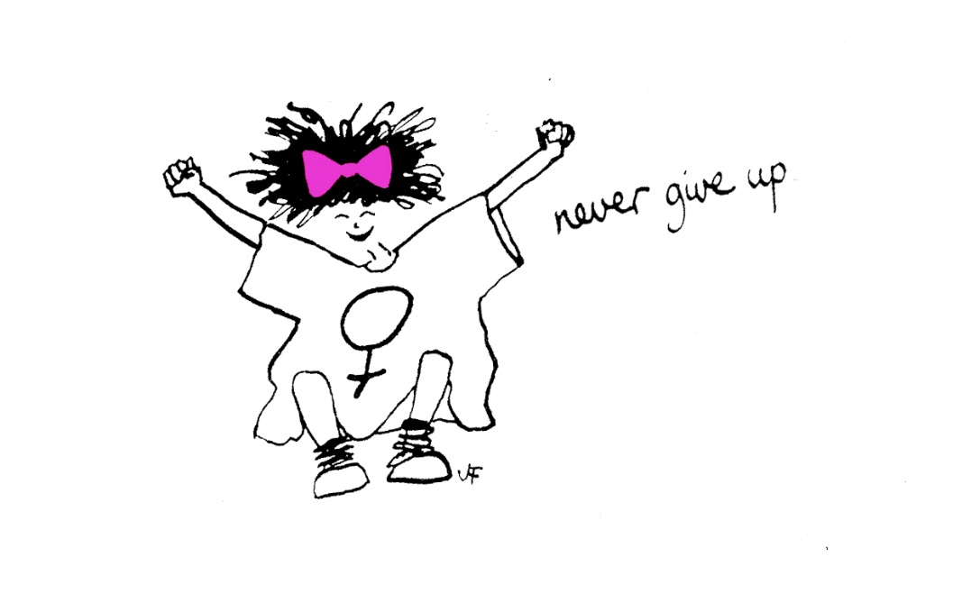

Evaluation of The Freedom Programme – Online
January to April 2021.
Sharon Bryan Consultancy Community Interest Company.
Company Number: 12882606.

Introduction
This evaluation examines the efficacy of The Freedom Programme. Through a quantitative assessment, this evaluation examines the impact and outcomes of the Freedom Programme for participants of the online group programme, which was conducted between January 2021 and April 2021.

Impact of COVID-19 and subsequent lockdowns.
Since the inception of the COVID-19 pandemic and subsequent national lockdowns, the Freedom Programme has not been able to run in the normal way, which has historically been face to face group sessions. Instead, login details for the Freedom Programme Online are purchased for £12 each and given to the women that have been offered a place on the online group programme, along with instructions on how to access the online programme on the national Freedom Programme website.
Conducting the programme online has its advantages and its disadvantages! The main disadvantage is that the group sessions lack the physical connection that women often feel is important.
“It is harder to connect with the other women when it is online. I think it would have been nice to have been able to give each other a cuddle when one of us became upset, but obviously, we can’t do that online”.
The obvious advantages of the programme being online are that women can attend from anywhere in the country or even the world! It is much more cost effective to run a programme online as there are no fees for venue hire or childcare. When a physical programme is run, we also give out copies of ‘Living with the Dominator’ and ‘The Home Study Course’ to each woman. By giving the women access to the online programme, they have access to the same content, but this is also cheaper to purchase than the books. For the women, there is obviously the advantage of not having to travel or leave their homes. However, this can be a disadvantage for women who are still living with the abusive partner or who have children who are not in school, particularly during the pandemic when schools have been closed.

Aims of The Freedom Programme.
The Freedom Programme is a support group designed for women who are or have been experiencing domestic abuse. The Freedom Programme is designed as an intervention to empower women to make positive choices about their lives by providing information and support, within a group setting. It gives women an opportunity and space to develop ways of thinking and behaving to protect themselves and their children from harm.
The aims of The Freedom Programme are:
- To help women understand the beliefs held by abusive men and in doing so, recognise which of these beliefs they have shared.
- To illustrate the effects of domestic abuse on children.
- To assist women to recognise potential future abusers.
- To help women gain self-esteem and the confidence to improve the quality of their lives.
- To introduce women to other women who share similar experiences.
The Freedom Programme comprises 11, 90-minute sessions held weekly and run by a qualified facilitator.
The Freedom Programme was developed in the UK by Pat Craven who works in the area of domestic abuse.

Evaluation Methodology
The information was collated using client questionnaires with qualitative and quantitative questions. For the purposes of evaluation, a section was added in relation to completing the programme online via zoom.

Process
- The client questionnaires were sent out by email after 9 sessions of the programme had been completed.
- Attendees were told there was no obligation to complete the questionnaire.

Response Rate
There were 18 women who completed The Freedom Programme. Of these women, 7 completed all 11 sessions and the remaining 11 women completed between 6 and 10 sessions. Out of the 18 women who completed the programme, 17 returned their questionnaires.

Main Findings
The analysis was very positive. The main quantitative findings are outlined below.
- 100% of participants said The Freedom Programme had a positive impact on their lives.
- 13 of the participants said they found The Freedom Programme very helpful, 3 found it helpful and 1 found it a little helpful.

Because of their participation in The Freedom Programme
- 9 participants strongly agreed, that the programme has resulted in a positive change in their lives. 7 agreed and 1 disagreed.
- 10 participants strongly agreed they are more hopeful for the future. 3 agreed and 4 disagreed. All 4 who disagreed felt this was because they still felt very raw about their experiences.
- 9 participants strongly agreed that they are more assertive. 7 agreed and 1 strongly disagreed but felt this was because she was still with her abusive partner.
- 10 participants strongly agreed that they were more confident. 6 agreed and 1 strongly disagreed and felt this was because she was still with her abusive partner.
- 8 participants strongly agreed they no longer blame themselves for their abuser’s behaviour and 9 agreed.
- 11 participants strongly agreed that they can now make more sense of their abusers’ behaviour. 5 agreed and 1 disagreed as she said there was only ever 1 incident of abuse which was physical and had never happened before in a long relationship, so she struggled to make sense of it.
- 15 participants strongly agreed they now feel less along in their experience of domestic abuse. 1 agreed and 1 disagreed.
- 13 participants strongly agreed that they now expect to be respected. 3 agreed and 1 disagreed.
- 9 participants strongly agreed that they can now recognise and identify abusive behaviour and 8 agreed.
- 7 participants strongly agreed that they feel they have the ability to respond to abusive behaviour and 10 agreed.
- 11 participants strongly agreed that they could now recognise an unhealthy relationship and 6 agreed.
- 13 participants strongly agreed that they understood more about the impact of domestic abuse on children and 4 agreed.
As well as the quantitative findings, women had the opportunity to explain their reasons for selecting their answers. The main themes that emerged from the qualitative questions were:
- The programme provided a safe and supportive space to talk about and explore the different types of domestic abuse.
- The benefit of meeting other women in the same or similar situations.
- Some of the women would of liked the programme to be longer because they felt they got so much out of it,
- The programme was educational and liberating.
- More awareness of the impact of their actions on their children.
- Realisation that the abuse was not their fault.
- Awareness of the ‘warning signs’ for future relationships.

Detailed Analysis
Overall impact of The Freedom Programme
The overall impact was very positive with 100% of those who completed the questionnaire saying that The Freedom Programme had a positive impact on their lives.
What were the impacts of The Freedom Programme?
- Knowing I’m not alone and shared experience as well as support.
- “I feel more confident that the abuse wasn’t my fault”.
- “I feel I now know what to look out for. The warning signs as such”.
- “It gave me the knowledge about different types of domestic abuse I wasn’t aware of and taught me the effects it can have on a woman’s life and children’s lives and development”.
- “Until starting the FP I didn’t realise how much abuse my ex-partner put me through or how much I wasn’t aware of the effects had on my kids”.
- “Enabling me to understand my current situation better”.
- “This has taught me that the behaviour I had witnessed from past relationships was not OK and has taught me I deserve to be treated with respect and kindness”.
- “Overall the impact I would generally say was life changing. It has completely opened my mind and I am able to look at what happened to me differently. What I mean by differently is being able to understand how he controlled me and how he persuaded me, lied to me to mould me into something he wanted”.
- “The Freedom Programme has made me feel empowered and ready to move on with my life. I now recognise behaviour as abusive that I didn’t even see before. I no longer blame myself for my partner’s behaviour, and I will be vigilant in remaining not in contact with him. Moving forwards, I believe I will better recognise early signs of abusive behaviour and leave. Even if I do end up in a similar situation, I also know who to contact and ask for help from for the best possible response”.
- “Realising that I am not going mad and he knew what he was doing”.
- “Understanding of different methods of control/dominance”.
- “To give a little background, I had left my abuser only a month before I started The Freedom Programme. Fleeing from an abusive relationship left me with so many feelings and I was overwhelmed. The Freedom Programme has helped me to deal with many of these feelings in a positive way. For example, understanding how abusers behave and think and where these beliefs come from has given me an overall insight into domestic abuse which I was lacking, and my intense confusion about my situation i.e. how I got into it, how it persisted for so long and why I couldn’t leave the situation for the longest time, has been resolved to a great extent. Speaking with others about abusive experiences has made me feel less alone and isolated and that I have a supportive, understanding community. My fears of being abused again in the future and making similar mistakes have been somewhat alleviated by starting to work toward knowledge and understanding to spot warning signs earlier on in a relationship, which the Freedom Programme teaches. While doing The Freedom Programme, I have been made more aware of the need to develop assertiveness, confidence and self-belief – and have been making steps towards implementing these traits in my life. The Freedom Programme provides a safe place to discuss abuse experiences and concerns of the utmost personal and sensitive nature – this is so valuable for people like me who leave abusers and I’ve been at my most vulnerable recently”.
- “Provided a safe and supportive space to talk about and explore different types of domestic abuse. How we are affected and what to be aware of in the future. It has made me realise how many women truly are affected by domestic abuse, from all walks of life, and just how much this affects not only them, but their family, children etc for a long time after they have even left the relationship. This makes me incredibly angry at how abuse of women and girls is so normalised in society and definitely inspires me to want to get involved and raise awareness and provide support for young women and girls and try to open these conversations up from a much younger age which could hopefully equip them with the tools to notice abusive relationships before they enter them and without having to go through one to learn this!”.
Overall rating of the usefulness of the programme by participants ***
100% of course participants listed the programme as being helpful with 13 of the participants saying they found it very helpful.
- “I am not and was not in a typical DV relationship, but the programme has highlighted what I should look out for if I can ever bear to date anyone again!”
- “Because I feel like learning has about his behaviour has taken the power away from him”.
- “Its extremely educational and at no point judges or puts blame on us for what we went through and how we reacted to abuse. Being able to talk so candidly in a group full of other women from all different ages and backgrounds about domestic violence was liberating. I knew no matter what stories I told I would receive the upmost support, and I never felt bad for asking questions or voicing my opinion”.”.
- “Before I started The Freedom Programme I believed it was my fault and believed a lot of what went on was normal, but doing the freedom programme managed to completely change my mind. Doing the programme helped me realise how my ex-partner manipulated me and how he mentally and physically abused me to his satisfaction”.
- “It has provided me with a community of women who have been a support and who have listened to me and shared experiences that made me feel not alone”.
- “It teaches you about the tactics of the dominator”.
- “Because it has given me more insight and understanding and how to be more aware of it in the future”.
- “I have learnt about how to be more aware and look for the signs before entering into another relationship in the future”.
- “When the legal system and the social services let us down after we left in tiny little broken pieces after years of abuse. I found this programme as the light at the end of the tunnel and that there is some one protecting us and guiding us to walk free and knowing there is always hope makes me feel stronger and safe. Someone who believes us and someone we can trust”.
- “I feel all women would benefit from The Freedom Programme”.
- “Because it has made me more aware of domestic abuse and its effects on children”.
- “The Freedom Programme has had a very positive impact on my life. It has been greatly helpful and provided support and knowledge at a very difficult, painful and confusing time in my life. Not only has it equipped me with a basis of knowledge so that I can hopefully live an abuse free future, having sich a good experience with The Freedom Programme has made me more confident to speak out and seek help when I need it, in the form of therapy, support groups and more programmes. This course is really comprehensive and insightful guide to domestic abuse. I don’t believe that there are many other courses like it, that follow the traits and aspects of the ‘Dominator’ in such an organised and structured way”.
- “Identification of different types of abuse”.
Which session did you find most useful?
- “All of them”.
- “The most useful sessions for me were the headworker and the jailor. I think it was really important for me to understand and to really reflect on how these psychological abuse tactics work as some of the tactics are subtle and yet really damaging”.
- “I can’t really pick one session over another as they were all useful in different ways”.
- “The Headworker”.
- “All of them. I couldn’t single out just one”.
- “Each session has been very positive to move on and learn and understand”.
- “The Liar as I could very much relate my past relationship to that”.
- “Effects on Children. The bad father and the headworker”.
- “All of them equally”.
- “The Headworker”.
- “The Liar”.
- “The sessions I found most useful was the persuader and the king of the castle. In these sessions it opened my mind on how my ex would manipulate me into cleaning and doing all the housework and persuade me into staying and believing I was in the wrong and deserved to be beaten up”.
- “The Persuader. It tied together everything we had learned about the dominator into the final stage where they either convince us to stay or we leave”.
- “Learning about the badfather as its taught me what to look out for as out son grows up”.
- “Sexual controller or head worker”.

Which session did you find least useful?
- “The badfather and the effects on children, only because I don’t have children”.
- “The session about the sexual controller as this was not my experience and it was very difficult listening to the awful experiences of other ladies”.
- “None of them, but personally because I don’t have children the ‘badfather’ was not relevant to my situation. However, it was still helpful for the future to learn about how abusive men treat their children”.
- “The session I found least useful was the bad dad session as I don’t have kids, but I am grateful for doing it as I am aware on how such things can have an impact on children. I grew up watching my dad beat my mum up and to some extent believed this was the norm and made me think this made a man more manly which maybe resulted in me going with an abuser aswell”.
- “None”.
- “Impact on children because I don’t have any”.
- “N/A”
- “N/A”.
- “None”.
- “Each session has been very positive to move on and learn and understand”.
- “none of them”.
- “None”.
- “The badfather as I don’t have children so could not relate”.
- “It depends on everyone’s experience and I don’t think any session would be useless”.
Other suggestions/feedback
Participants were asked for any other comments or feedback.
- “The facilitator was amazing and I felt so connected with her throughout the course”.
- “Sharon has created a very safe, supported and comfortable environment for everybody to share their experiences to guide us all through the course”.
- “I think the programme has been run brilliantly and think this should be provided on a much larger scale to raise awareness of domestic abuse, especially for professionals, social workers, even judges and lawyers etc, that deal with domestic abuse on a daily basis yet seem to have no understanding of the nature and impact of it on the victim and children”.
- “It has been a pleasure and I am extremely grateful to be part of sharon’s programme. She has been amazing and supportive, her experience, knowledge, faith and courage are an example to me”.
- “Lots of stories to be heard and information to move on with our lives, sometimes we are left without resources, knowledge, support but having this type of programme is very good for all of us especially after we have our freedom”.
- “I feel a bit sad the programme has ended and would love to be part of a refresher programme to get together from time to time. I believe it would be nice and helpful to keep going and help us to get stronger. This programme is very good, maybe a bit longer would be better. I got used to this programme as it has been extremely powerful and positive for me”.
- “Sharon was great and she was very friendly which gave me the confidence to talk to her easily and the way she did the programme helped me to understand about domestic violence and gain more confidence in being able to identify the signs before entering into another serious relationship”.
- “I would recommend Sharon to anyone who has been through domestic violence as she empowers women in this situation for a better future for themselves and their children. I thanks Sharon so much and will maybe do more about domestic violence with her depending on what she has to offer”.
- “Honestly, I am so grateful for the kindness and lessons I have been taught. I feel so valued”.
- “Sharon was more than helpful, understanding and supportive. She has truly left a positive impact on me and I believe everyone aswell”.
- “The Freedom Programme has completely changed how I see myself and my abusive relationships in the past. I went into the programme still heavily blaming myself for what had happened, but I am now more at peace. Ending the programme feels like the final step of closure I had to cultivate for myself”.
- “I’d like the programme to have been longer but only because I got so much out of it”.
- “Going round choosing someone at random to speak is a great method but it was hard for Sharon to keep that going all the time. It helped me grow in confidence knowing that I would need to talk but I realise not everyone likes that”.
- “For me personally, I still don’t understand why my ex-partner did what he did. I guess I never will. It was a one off attack, he has not been in touch since so I struggle to see that it was control”.
Conclusion
This evaluation of The Freedom Programme is extremely positive. The was conducted in the evening to allow women to settle young children. This seemed to work very well.
Obviously, with the nature of the programme, there were times when participants became distressed, when speaking about their experiences. Being an online virtual programme there was clearly an absence of being able to physically reassure and comfort women in the group – something I feel is a disadvantage of holding the programmes virtually. However, as with the last group programme members the women in this programme set up a WhatsApp group between them so that they could message each other in between sessions, if they felt they needed extra support. I was part of this group but only for the purposes of monitoring it and the women knew this.
Overall, all women who attended and completed the programme stated that they felt more empowered and ready to face the future with more understanding of their experiences.

Sharon Bryan
Sharon Bryan Consultancy Community Interest Company
Company Number: 12882606
April 2021.

